**ON-DEMAND CAR WASH SYSTEM**

**(LLD)**

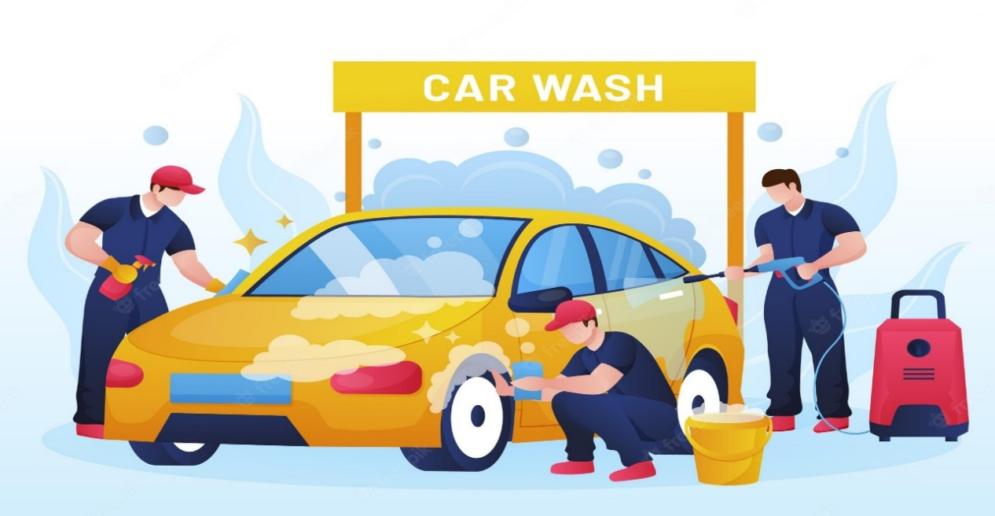

**DOCUMENT APPROVAL**

**Approvers of this document**

|  |  |  |  |  |
| --- | --- | --- | --- | --- |
| **Name** | **Department** | **Role** | **Signature** | **Date** |
|  |  |  |  |  |
|  |  |  |  |  |
|  |  |  |  |  |

**DOCUMENT CHANGE HISTORY**

|  |  |  |  |
| --- | --- | --- | --- |
| **Document Version #** | **Author** | **Date** | **Description** |
|  |  |  |  |
|  |  |  |  |
|  |  |  |  |
|  |  |  |  |

**Table of Contents**

1. **Document Purpose**
2. **Overview**
3. **Roles**
4. **Design Pattern**
5. **Solution Diagram**
6. **Solution Steps**
7. **Classes/Functions**
8. **Class Diagram**
9. **Tables**
10. **Activity Diagram**
11. **Use Case Diagram**
12. **ER Diagram**

1. **Document Purpose**

This document describes the solution architecture for Customer management microservice

**2.0 Overview**

Tell us about your car location, and we will come to you. With Green Wash, you can get your car washed wherever you are at your convenience. Whether it's your home, salon, office, or any other place, your car wash is just a few taps away. Few moments spend in signup can save you valuable time. All you need to do is just enter your car, address, and payment details. A washer will come to your location and give your vehicle a premium wash. The app also contains various packages and add-ons to wipe, clean, and dress your entire car from inside out. One of the app's best parts is that users can even schedule future car wash and give reviews and ratings to washers. Just download the app now and book your first car wash today.

**3.0 Roles:**

* Customer
* Car washer
* Admin

**4.0 DESIGN PATTERN**

|  |  |  |
| --- | --- | --- |
| S.NO | NAME | DESCRIPTION |
| 1 | ASP.NET WEB API | Using HTTP requests, we will use the respective action to trigger various operations |
| 2 | HTML&CSS  ASP.NET MVC | To create and design the frontend. |
| 3 | DATABASE(SQL SERVER) | To store and retrieve the information. |

**5.0 SOLUTION DIAGRAM**

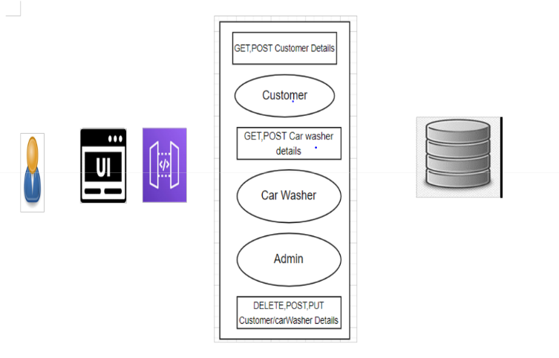

**6.0 SOLUTION STEPS**

**Customer Registration**

1. User will enter the required details such as Name, email, phone number, and click submit button browser directs the request to customer registration API.
2. Call reaches the API gateway.
3. API gateway does the routing and forward the requestregisterCustomerHandler.handle and this handles function will call the doProcess().
4. doProcess() will call the customerschemaValidator.dovalidate() function do the input validation it will have
   1. If validation fails, then it will return the error code and error description. with status code
   2. If validation is successful, then the handler will callregisterCustomerservice.registerCustomer() which will call

registerCustomerRepository.registerCustomer() to store the data in database

1. It sends a response body with HTTP Success response to registerCustomer.
2. registerCustomerHandler returns the JSON result.
3. Success JSON response and HTTP status code 200 with corresponding success message.

**7.0 ARCHITECTURAL DIAGRAM**

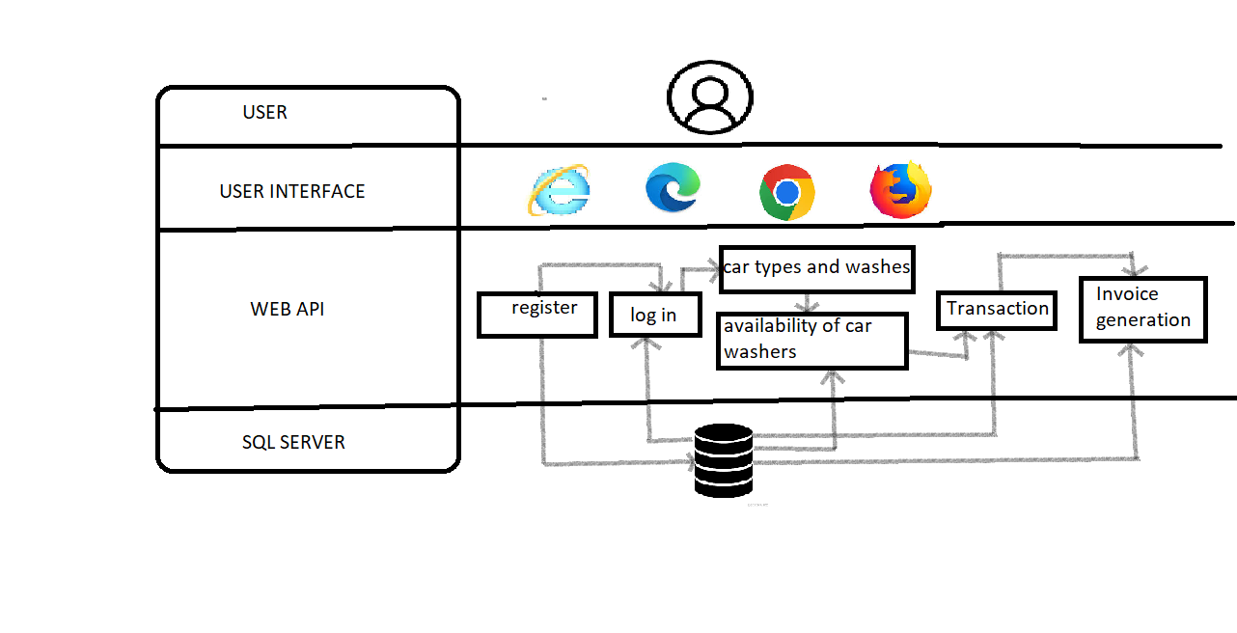

.

**8.0 Classes/function**

|  |  |  |  |  |  |
| --- | --- | --- | --- | --- | --- |
| **#** | | **Class** | | **Description** | |
| 1 | | Customer.js | | Model holds the customers schema details | |
| 2 | | registerCustomerHandler.js | | The handler to handle the registration of customers which calls the registerCustomerService class | |
| 3 | | CarWasher.js | | Model holds the carwasher schema details | |
| 4 | | Admin.js | | Model holds the admin schema details | |
| 5 | | WashType.js | | This model contains the what type of wash did customer requires |
| 6 | | Payment.js | | It contains the core business logic for the payment method of customers |
| 7 | | Cost.js | | This class deals with the cost maintained for wash . |

**9.0 CLASS DIAGRAM**

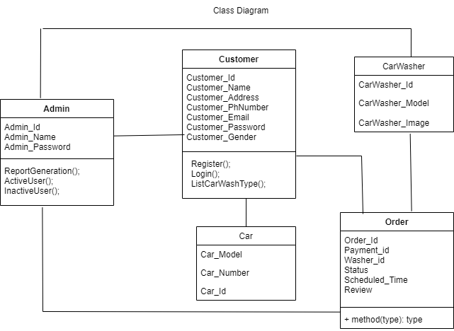

**10.0 TABLES:**

|  |  |
| --- | --- |
| **Customer Table** |  |
|  |  |
| **Customer Details** | **DataType** |
| CustomerId | int |
| CustomerName | varchar(50) |
| Email | varcha(100) |
| Address | varchar(50) |
| Gender | varchar(50) |
| PhoneNumber | int |
| CarNo | int |
| CarModel | varchar(50) |
| Car Colour | varchar(50) |

|  |  |
| --- | --- |
| **Car Washer Table** |  |
|  |  |
| **WasherDetails** | **Datatype** |
| Id | int |
| Name | varchar(50 |
| Email | varchar(100) |
| Gender | varchar(50) |
| PhoneNumber | int |
| TrackId | int |
| Ratings | int |

|  |  |
| --- | --- |
| **Admin Table** |  |
|  |  |
| **AdminDetails** | **DataType** |
| AdminId | int |
| AdminName | varchar(50) |
| Email | varchar(100) |
| AdminContact | int |

**11.0 ACTIVITY DIAGRAM**

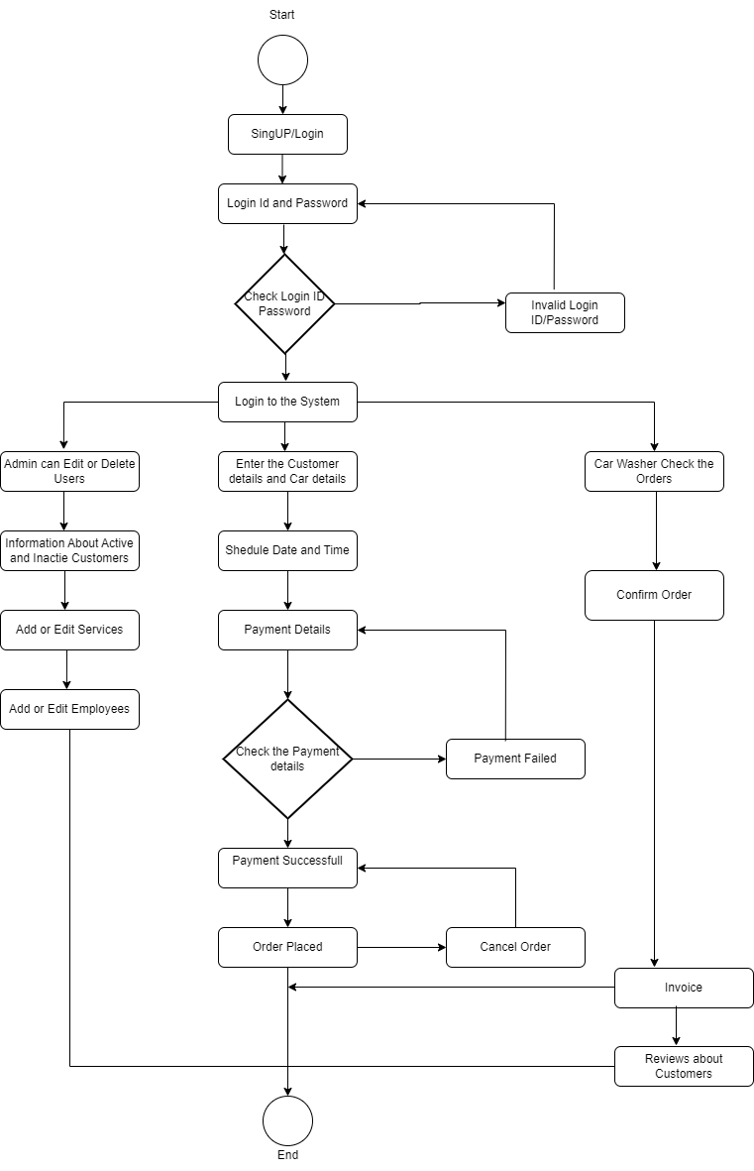

**12.0 USE CASE DIAGRAM**

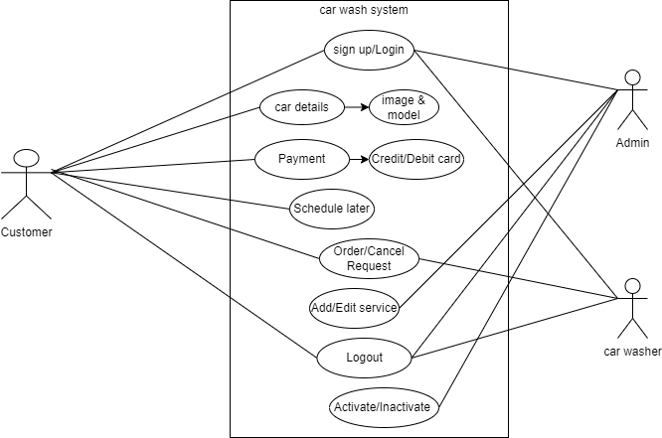

**13.0 ER-DIAGRAM**

